
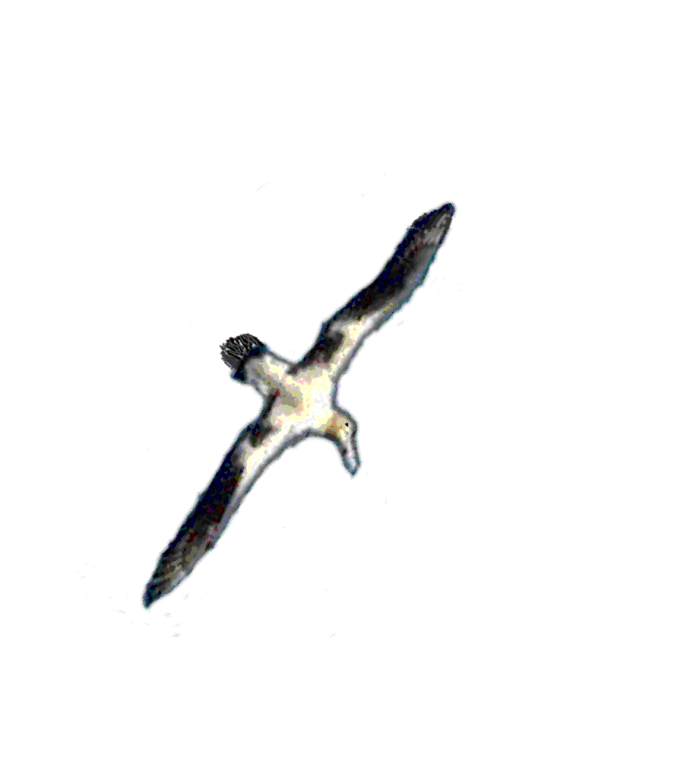


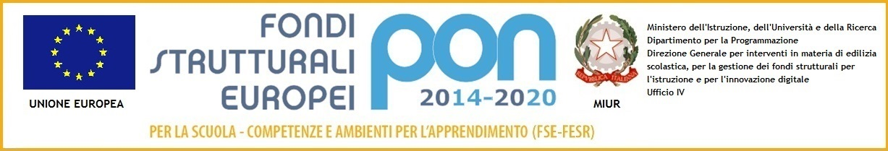
IN VOLO VERSO IL FUTURO
CON LE RADICI NEL PASSATO
R E T E I S T I T U T I S C O L A S T I C I
d e l V A L D A R N O
ISTITUTO COMPRENSIVO “F. MOCHI”
Via Milano, 20 - 52025 LEVANE (AR) - Tel. 055-97.88.015
Fax: 055/9180347 – E-mail:
ARIC820006@istruzione.it
CODICE FISCALE: 81005070511

DOCUMENTO DI PROGRAMMAZIONE
DELLE ATTIVITA’ EDUCATIVE E DIDATTICHE
Scuola dell’infanzia

A.S. __________ / ___________

Plesso di _________________

Gruppo: _________________

- ANALISI DELLA SITUAZIONE INIZIALE
________________________________________________________________________________________________________________________________________________________________________________________________________________________________________________________________________________________________________________________________________________________________________________________________________________________________________________________________________________________________________________________________________________________________________________

- OBIETTIVI FORMATIVI
________________________________________________________________________________________________________________________________________________________________________________________________________________________________________________________________________________________________________________________________________________________________________________________________________________________________________________________________________________________________________________________________________________________________________________________________________________________________________________________________

- MODALITA’ DI LAVORO
________________________________________________________________________________________________________________________________________________________________________________________________________________________________________________________________________________________________________________________________________________________________________________________________________________________________________________________________________________________________________________________________________________________________________________________________________________________________________________________________

- ATTIVITA’
________________________________________________________________________________________________________________________________________________________________________________________________________________________________________________________________________________________________________________________________________________________________________________________________________________________________________________________________________________________________________________________________________________________________________________________________________________________________________________________________

- ALTRI ACCORDI
________________________________________________________________________________________________________________________________________________________________________________________________________________________________________________________________________________________________________________________________________________________________________________________________________________________________________________________________________________________________________________________________________________________________________________________________________________________________________________________________

Le docenti

_____________________________________
_____________________________________
_____________________________________

